
Operating

System

Lab

(
N
-
PCCCM401P)

S.B.

JAIN

INSTITUTE

OF

TECHNOLOGY
MANAGEMENT

& RESEARCH,

NAGPUR

Practical
06

Aim:
Considered there are N philosophers seated around a circular table with one
chopstick between each pair of philosophers. There is one chopstick between

each
philosopher. A philosopher may eat if he can pick up the two chopsticks adjacent to
him. One chopstick may be picked up by any one of its adjacent followers but not
both.

technique.

Academic Session:

Write a program to solve the problem using process synchronization
Name: Sakshi D. Ambarte
USN: CM24041
Semester / Year:
Date of Performance:
Date of Submission:
4
th / 2nd
2025-2026
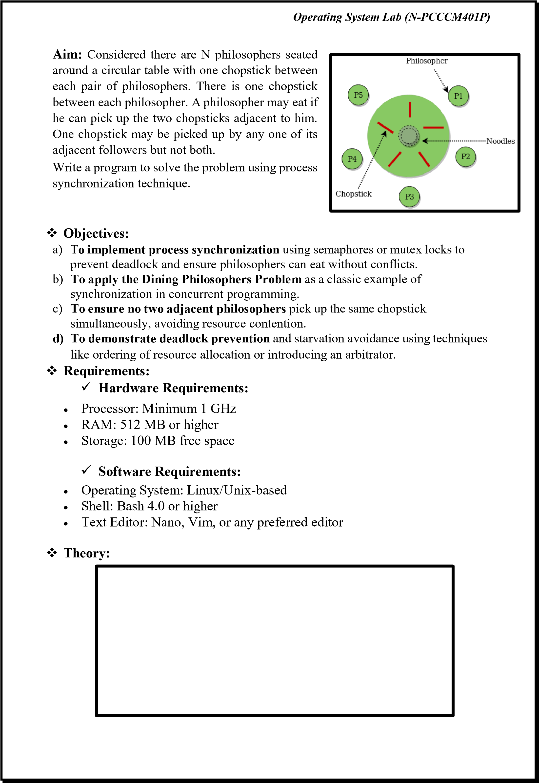
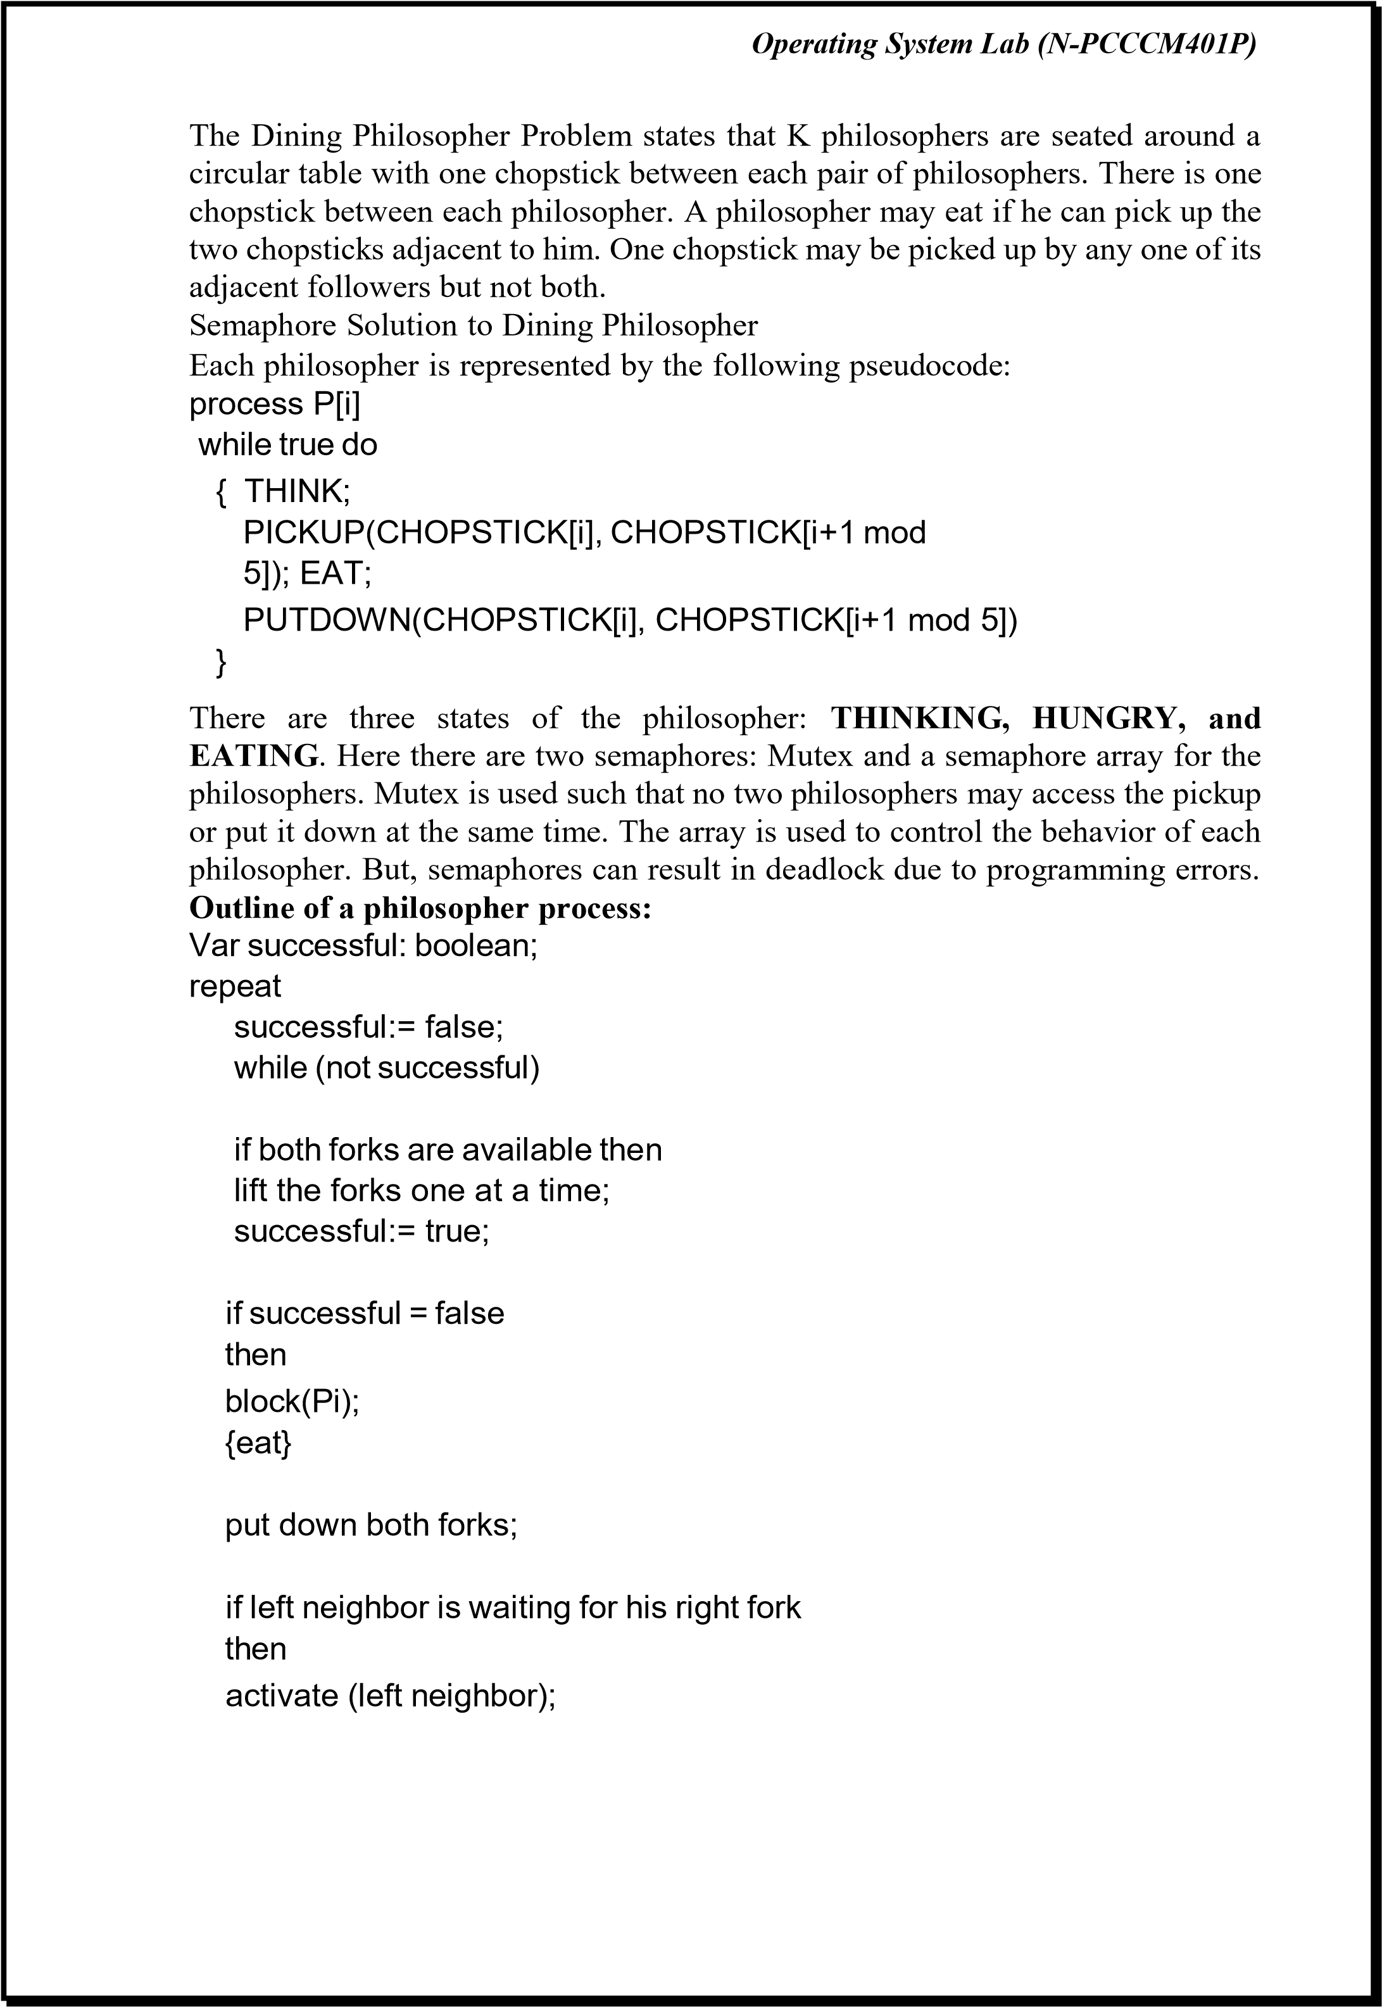
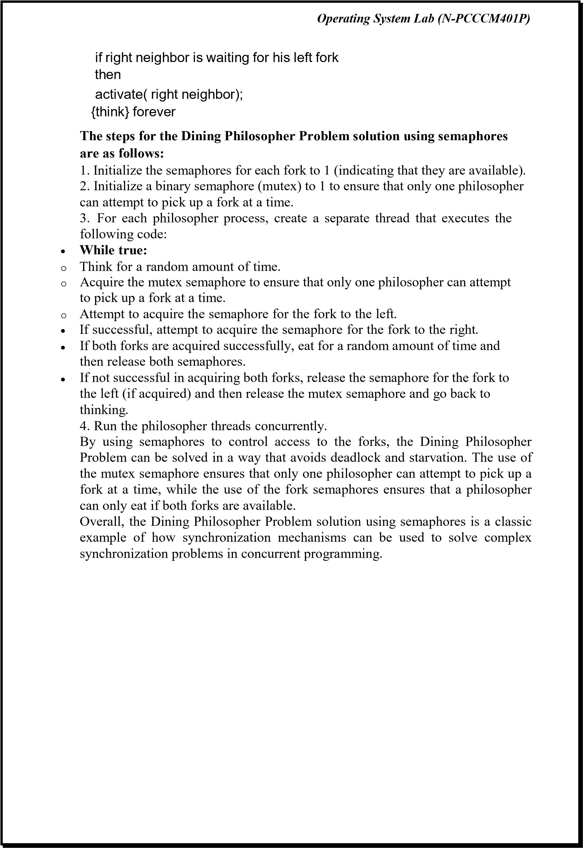
Operating

System

Lab

(
N
-
PCCCM401P)

Implementation

of

the

Dining

Philosopher

Problem

solution

usi
ng

semaphores
in Python

CODE:

#include <stdio.h>

#include <stdlib.h>

#include <pthread.h>

#include <semaphore.h>

#include <unistd.h>

#define N 5 // number of philosophers

#define THINKING 0

#define HUNGRY 1

#define EATING 2

sem_t
chopsticks[N]; // one semaphore per chopstick

pthread_t philosophers[N];

int philosopher_id[N];

void think(int id) {

printf("Philosopher %d is thinking...
\
n", id);

sleep(rand() % 3 + 1); // simulate thinking for 1
-
3
seconds

}

void eat(int

id) {

printf("Philosopher %d is EATING.
\
n", id);

sleep(rand() % 2 + 1); // simulate eating for 1
-
2
seconds

}

void* philosopher_life(void* arg) {

int id = *(int*)arg;

int left = id; // left chopstick index

int right = (i
d + 1) % N; // right chopstick index

while (1) {

think(id);

// Asymmetric pickup order to avoid deadlock

if (id % 2 == 0) {

// Even: pick left first, then right

sem_wait(&chopsticks[left]);

printf("Philosopher %d picked up left chopstick %d
\
n", id, left);

sem_wait(&chopsticks[right]);

printf("Philosopher %d picked up right chopstick %d
\
n", id, right);

}

Operating

System

Lab

(
N
-
PCCCM401P)

else {

// Odd: pick right first, then left

sem_wait(&chopsticks[right]);

printf("Philosopher %d picked up right chopstick %d
\
n", id, right);

sem_wait(&chopsticks[left]);

printf("Philosopher %d picked up
left chopstick %d
\
n", id, left);

}

eat(id);

// Put down both chopsticks

sem_post(&chopsticks[left]);

sem_post(&chopsticks[right]);

printf("Philosopher %d put down chopsticks
\
n", id);

}

return NULL;

}

int main() {

srand(time(NULL));

// Initialize semaphores for chopsticks

for (int i = 0; i < N; i++) {

sem_init(&chopsticks[i], 0, 1);

philosopher_id[i] = i;

}

// Create philosopher threads

for (int i = 0; i < N;

i++) {

pthread_create(&philosophers[i], NULL, philosopher_life,
&philosopher_id[i]);

}

// Wait for threads (they run forever, but we keep main alive)

for (int i = 0; i < N; i++) {

pthread_join(philosophers[i], NULL);

}

// Cleanup (never reached in this example)

for (int i = 0; i < N; i++) {

sem_destroy(&chopsticks[i]);

}

return 0;

}

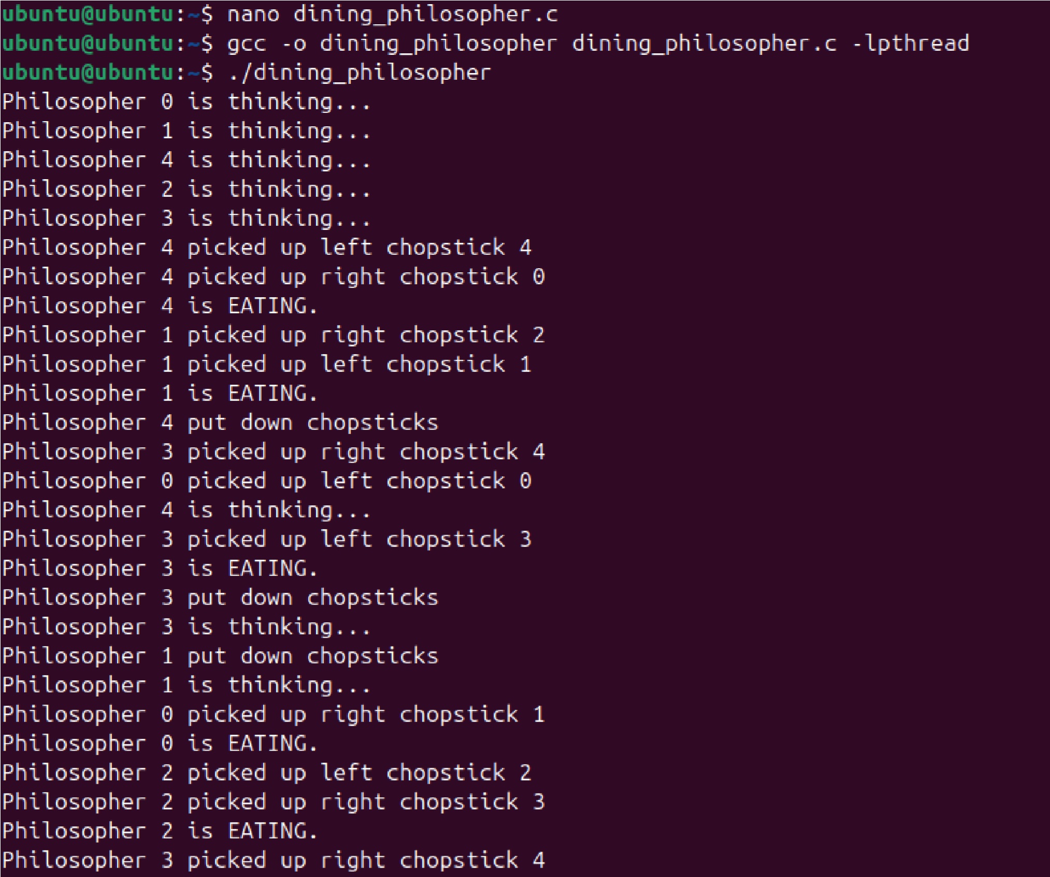
Operating

System

Lab

N
(
-
PCCCM401P)

OUTPUT:

As

you

can

see

from

the

output,

each

philosopher

takes

turns

thinking

and

eating,
and there is no
deadlock or starvation.

Problem

with

Dining

Philosopher

We have demonstrated that no two nearby philosophers can eat at the same time
from
the
aforementioned
solution
to
the
dining
philosopher
problem.
The
problem with the above solution is that it might
result in a deadlock situation. If
every philosopher picks their left chopstick simultaneously, a deadlock results,
and no philosopher can eat. This situation occurs when this happens.

Some

of

the

solutions

include

the

following:

1.

The maximum number of phil
osophers at the table should not exceed four; in
this case, philosopher P3 will have access to chopstick C4; he will then begin
eating, and when he is finished, he will put down both chopsticks C3 and C4;

Operating System Lab (N-PCCCM401P)
as a result, semaphore C3 and C4 will now be incremented to 1.
- Now that philosopher P2, who was holding chopstick C2, will also have chopstick C3, he will do the same when finished eating, allowing other philosophers to eat.
- While a philosopher in an odd position should select the right chopstick first, a philosopher in an even position should select the left chopstick and then the right chopstick.
- A philosopher should only be permitted to choose their chopsticks if both of the available chopsticks (the left and the right) are available at the same time.
All four of the initial philosophers (P0, P1, P2, and P3) should choose the left chopstick before choosing the right, while P4 should choose the right chopstick before choosing the left. As a result, P4 will be forced to hold his right chopstick first because his right chopstick, C0, is already being held by philosopher P0 and its value is set to 0. As a result, P4 will become trapped in an infinite loop and chopstick C4 will remain empty. As a result, philosopher P3 has both the left C3 and the right C4. chopstick available, therefore it will start eating and will put down both chopsticks once finishes and let others eat which removes the problem of deadlock.
- Conclusion: In this practical, we conclude that process synchronization techniques, such as semaphores and mutex locks, effectively manage shared resources in concurrent systems. By implementing the Dining Philosophers Problem, we ensured deadlock prevention, starvation avoidance, and efficient resource allocation, demonstrating the importance of synchronization in multi-process environments. 
- Discussion Questions: 
- What is the main problem in the Dining Philosophers Problem?
- Which synchronization techniques can be used to solve this problem?
- How can deadlock be avoided in this problem?
- Why is starvation a concern in the Dining Philosophers Problem?
- What is the role of semaphores in solving this problem?

❖ References: 
https://www.geeksforgeeks.org/dining-philosopher-problem-using-semaphores/

Date: / /2026 Signature
Course Coordinator B.Tech CSE(AIML)
Sem: 4 / 2025-26

Operating System Lab (N-PCCCM401P)

